

*Press release*

*13 February 2023*

**The Mayan heritage in Belize :**

**4 archaeological sites to discover**

**A true Babel of the Tropics, Belize is certainly small in size but big in its cultural and ethnic diversity. The Belizean population forms a true mosaic of cultures which makes the richness of the country.**

**The Mayan communities, still present on the continent, constitute an important ethnic group in Belize. Rich of a thousand-year-old culture, the Maya have left behind them an invaluable heritage. More confidential but just as important as their Guatemalan or Mexican neighbors, these ancient Mayan cities are today the remains of a civilization that still hides many mysteries. From Cerros in the north to Lubaatun in the south, passing by Altun Ha and Caracol, the Mayan archaeological sites in Belize are real diamonds in the rough to explore.**

**Cerros: the archaeological site on the Mexican border**

The only Mayan site on the coast of Belize, the Cerros ruins are located near the northern town of Corozal. Cerros was a small port that developed in 50 B.C. until its decline around 150 A.D. Three main buildings make up the site. The tallest structure is 21 meters high and offers a panoramic view of the bay of Chetumal. The most famous temple of Cerros is decorated with painted stucco masks representing the rising and setting sun. The inhabitants of this city lived mainly from fishing and agriculture. They built ingenious systems of canals to control floods and to transport goods and materials of all kinds to serve agricultural production.

For more information, click [ici](https://www.travelbelize.org/fr/attraction/cerros/) .

**Altun Ha: place of discovery of the jade head**

Altun ha is the closest archaeological site to Belize City (about 30km). It is one of the major ceremonial sites in Belize and its name means "the rock of the pond" in Yucatecan Maya. At its peak, the city was part of the Tikal confederation and served as a commercial link between the coast and the interior. Altun Ha is particularly known for being the site of the discovery of more than 300 jade objects, the most important of which is the jade head of Altun Ha. This jewel in the crown of Belize is 14.9 cm high and weighs almost 5 kg. The sculpture representing the Mayan sun god Kinich Ahau is located in the heart of the Temple of the "Masonic Altars". A replica is on display at the Central Bank of Belize and his portrait is watermarked on all Belizean currency.

For more information, click [ici .](https://www.travelbelize.org/fr/attraction/altun-ha/)

**Caracol: the rival city of Tikal**

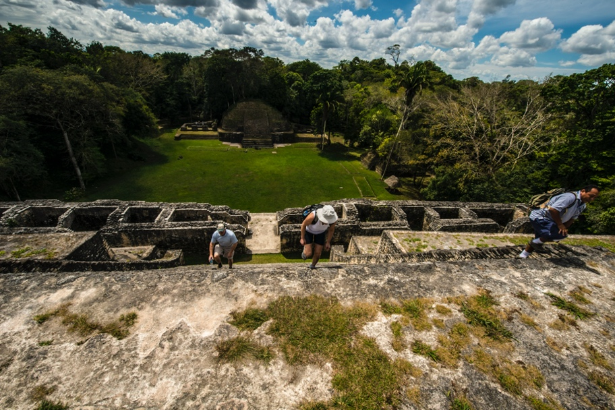

The ancient Mayan city of Caracol was one of the most important of its time. Located in the heart of the Chiquibul Nature Reserve in the Cayo District, it covers an area of over 10,000 hectares. Caracol is one of the best preserved Mayan sites in Belize. Its main temple is over 43 meters high and offers incredible views of the surrounding jungle. Thanks to the ingenuity of the Maya in pre-Hispanic times, speakers could be heard very easily by the crowds spread out in the main square. Caracol was also a major player in geopolitics during the recent classical period (6th and 7th centuries). At its peak, it had 100,000 inhabitants and was involved in several conflicts, notably as an ally of the city of Calakmul, in Campeche, Mexico, against that of Tikal, in Guatemala. Caracol is a must-see of the Mayan heritage in Belize.

For more information, click [ici.](https://www.travelbelize.org/fr/attraction/caracol/)

**Lubaantun: towards the south of Belize**

Lubaantun is located near the Mayan village of San Pedro Columbia, only 20 km from Punta Gorda, the main town in the Toledo District. This ancient Mayan city flourished for over 150 years, from about 700 to 850 AD, and is now the most important site in southern Belize. It consists of 14 structures grouped around five main plazas. The construction of the Lubaantun site is unique in that no mortar was used. Indeed, each stone was carefully selected, measured and cut to fit its neighbor. Lubaatun benefits from particularly fertile soils which were used for the production of cocoa.

In 1944, the adventurer Mitchell-Hedges claimed to have discovered a mysterious crystal skull in 1924, when he was excavating the ruins of the city, an object that he would have sold later. No proof has been able to confirm the facts until now. The story has at least had the merit of inspiring the story of adventure films such as Indiana Jones.

For more information, click [ici](https://www.travelbelize.org/fr/attraction/lubaantun/).

|  |  |  |  |  |
| --- | --- | --- | --- | --- |
| |  |  |  |  | | --- | --- | --- | --- | | |  |  |  | | --- | --- | --- | | |  |  | | --- | --- | | |  | | --- | | ***  **A propos du Belize Tourism Board (BTB)**| Le **Belize Tourism Board** fait partie du Ministère du Tourisme et de l’Aviation Civile du Belize, il est dirigé par un comité de direction désigné par le Ministère du Tourisme et de l’Aviation Civile. Le BTB, qui travaille conjointement avec les membres du secteur privé – dont l’Association hôtelière du Belize, l’Association de l’Industrie du Tourisme et l’Association Nationale des Tour Operateurs du Belize – s’attache au développement touristique et économique du pays sur le long terme, en veillant à respecter l’environnement local.  Pour plus d’informations sur le BTB et ses services: [www.travelbelize.org](http://www.travelbelize.org) – Suivre BTB sur les réseaux sociaux : Instagram, Facebook, YouTube. | | | | |

|  |  |  |  |  |  |  |  |
| --- | --- | --- | --- | --- | --- | --- | --- |
| |  |  |  |  |  |  |  | | --- | --- | --- | --- | --- | --- | --- | | |  |  |  |  |  |  | | --- | --- | --- | --- | --- | --- | | |  |  | | --- | --- | | |  | | --- | | **Contact presse :** Belize Tourism Board c/o GroupExpression Laure LE CORNEC : [laure.lc@groupexpression.fr](mailto:geraldine@groupexpression.fr) 06 81 57 60 43 | |  |  |  |  | | --- | --- | --- | | |  |  | | --- | --- | | |  | | --- | |  | | | | | |