UNITING LUXURY AND SUSTAINABILITY: EXPERIENCE LATIN AMERICA IN STYLE WITH CAZENOVE+LOYD

cazenove+loyd has operated across Latin America since 1996, arranging tailor-made holidays, expert-led small group trips and milestone celebrations for luxury travellers. Continuing our longstanding commitment to sustainable tourism, our forward-looking focus is to become a partner of The Long Run.
As we work towards membership of this organisation, we are actively championing its four Cs: Conservation, Community, Culture and Commerce, and are promoting itineraries that encapsulate these values through our lens – people, experiences and place – for a positive impact trip.

CONSERVATION
Check in to Casa Caiman and support local wildlife.
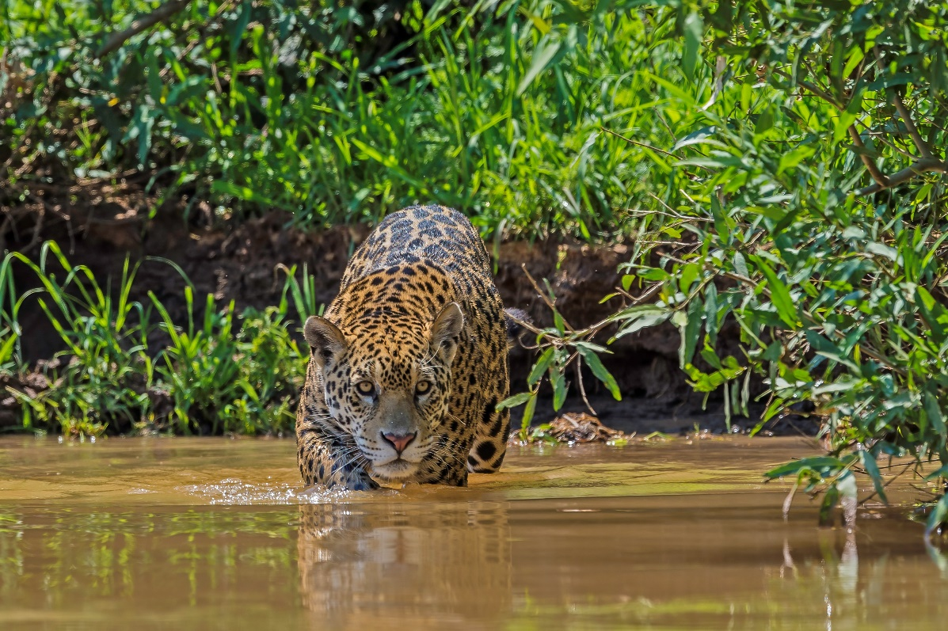

Founded more 30 years ago with the aim of conserving the fauna, flora and culture of the Pantanal, Caiman was a pioneer in believing in the benefits of ecotourism for the region. Its structure, unique in the Pantanal, brings together extremely cosy and comfortable accommodation, magical experiences in nature – all run by experts who know everything about the location – and delicious cuisine.
We love Casa Caiman for its impressive wildlife conservation efforts, which allow guests up-close and personal engagement with the 53,000-hectare site’s best-loved animals. The two signature experiences are monitoring hyacinth macaw nests alongside a biologist and tracking jaguars with the Onçafari Jaguar Project, an African safari-style concept and the first of its kind in the region.
Recently renovated, main lodge Casa Caiman has 18 suites, as well as several leisure options that enable travellers to relax in nature’s embrace. Two private, exclusive use villas are also available, with five and six rooms respectively, which include hotel service, private guides and a vehicle at your disposal.

COMMUNITY
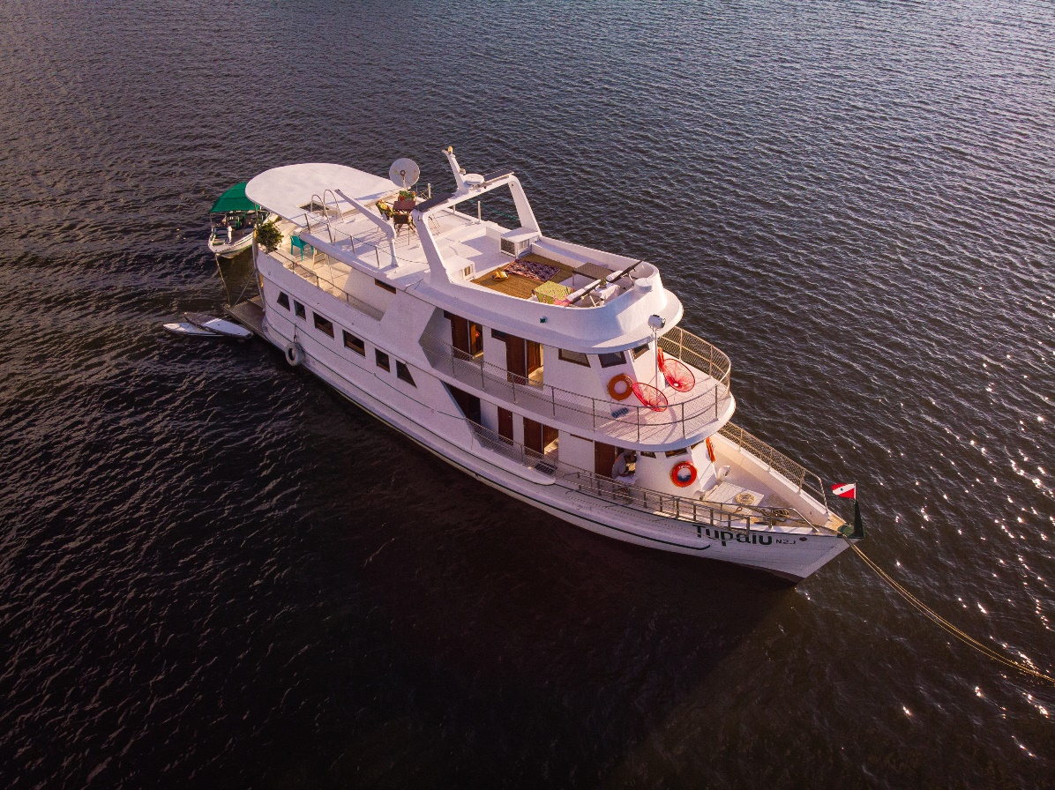
Meet the conservation gatekeepers of the Amazon aboard the Tupaiú.

Have you ever considered a private charter in the Brazilian Amazon? We have access to three luxury-to super-luxury, privately owned yachts, each sleeping 8 to 22 guests, including the magnificent 18-metre regional yacht, Tupaiú. Aboard this vessel, discover three different kinds of Amazonian ecosystems (black, yellow and blue waters), witness the region’s unparalleled biodiversity and interact with local communities living along the Tapajós river.
Comprising five airconditioned, ensuite cabins (three with double beds and two with bunk beds), Tupaiú is ideal for families looking for a personalised, private adventure. An internal living room, dining room and library for unwinding after a long day of jungle exploration join the large, shaded observation deck, which makes an excellent spot for a sundowner.
We supplement the captain and crew with an English-speaking chef, host and guide with deep knowledge of Amazonian communities, wildlife and local conservation initiatives. Spend time with locals and community leaders at Atodi, San Marcos, Coroca and Alter do Chao village as you sail along this glorious slice of the Amazon. Activities en route also include jungle survival skills and the chance to get involved in various conservation projects. A voyage aboard the Tupaiú in this incredible environment is both relaxing and life changing, but perhaps not for those who require 24-hour internet access! Our favourite routings fly into the remotest parts of the river system by floatplane to meet your yacht.

CULTURE
The Dominican Republic...it’s the Caribbean but not entirely as you know it.
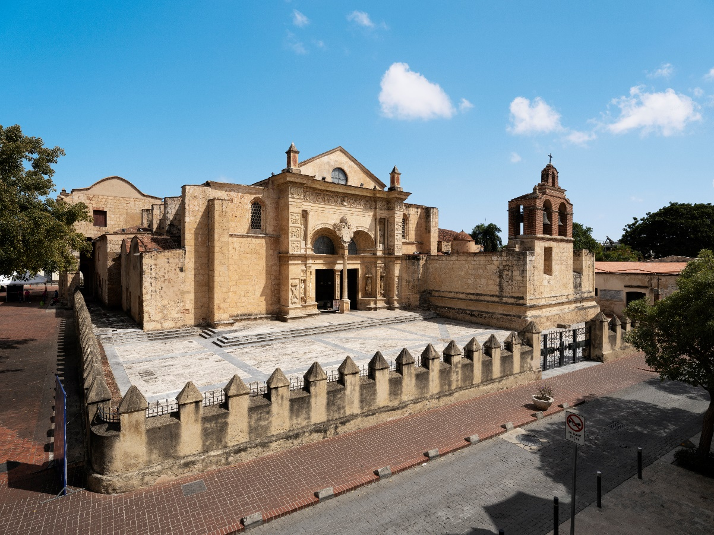

The Dominican Republic has a well-founded reputation as an incredible holiday destination but take the time to veer off the beaten track and you’ll discover a rich culture encompassing influences from around the world and a diverse range of extraordinary experiences that will surprise and delight. Here’s just a snapshot...the capital, Santo Domingo, was founded in the late 15th century and enjoys an architectural legacy that endures today; the oldest cathedral in the Americas was completed here in 1550, while most buildings in the Colonial Zone date from the 1700s. It’s not all about the past; this is a modern and vibrant city with fantastic restaurants, bars and bouncing nightlife – it has even featured in movies such as the Godfather part II.
The northern shore is the go-to destination for whale spotting, plus excellent snorkelling and diving opportunities, waterfalls, hiking, zip-lining and horse riding inland at El Valle. Santiago de Caballeros is well off the beaten path for most foreign travellers. With its neo-gothic cathedral and Victorian architecture, the bustling streets, markets and plazas are great fun to explore. At the Centro Leon you will find the best archaeological museum in the Dominican, alongside art galleries showcasing incredible talent, while overlooking the city is the Monumento de Santiago, dedicated to the heroes of the Dominican Restoration War. A rich country steeped in history; this island nation is begging to be discovered.
COMMERCE
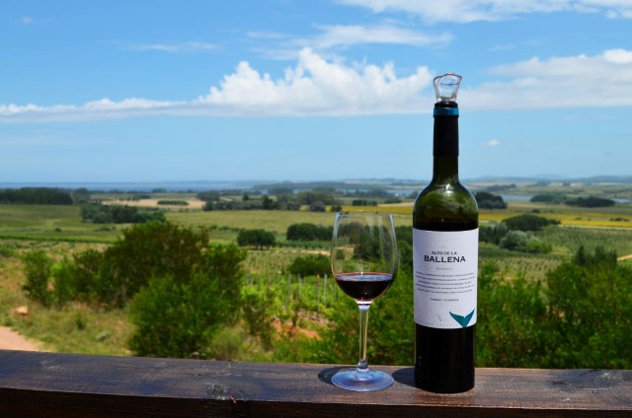
Drink in Uruguay’s boutique wine scene at Alto de Ballena.

When wine-loving couple Alvaro Lorenzo and Paula Pivel bought land on a gently sloping hill in Uruguays’s Maldonado region back in 2000, there wasn't a single vineyard in the area. Today, not only does Alto de Ballena’s sustainable, small-scale winery preserve a centuries-old tradition, but it is also a pioneer of Maldonado, producing circa 30,000 bottles per year, which are sold at gourmet stores and restaurants all over Uruguay as well as in Brazil, Mexico and Sweden.
While boutique in nature, it is one of the region’s leading producers, with the steep, granite and schist hillsides where Alto de Ballena’s eight hectares of vines are planted providing characterful terroir for their smooth, fresh and vibrant wines. Visits to this breathtaking winery are by appointment only and will include a tour – which we can arrange to be led by the charming owners themselves. The scenic grounds and alfresco west-facing deck are the perfect place to catch dreamy sunsets, complemented by a tasting of Merlot, Tannat or Syrah, served with local cheese.
Further examples of boutique wineries we love in Uruguay include El Quinton (Colonia), Los Nadies in Montevideo, where visitors can have dinner with the winemaker, and Sierra Oriental.
Website: www.cazloyd.com
Telephone: +44 (0)20 7384 2332

Social Links
Instagram: @cazenove_and_loyd

-ENDS-

For all press enquiries please contact:
Rebecca Milne; rebecca@cazloyd.com

Notes to editors:
About cazenove+loyd
cazenove+loyd (cazloyd.com; 020 7384 2332) has been pioneering impactful travel for more than 30 years. The company has established special connections that give unprecedented access to some of the world's most inspiring people and places, including exclusive private properties in their 'Unlocked' portfolio.
With personalised trips spanning six regions of the world – Africa + the Indian Ocean, Latin America, Asia + the Middle East, Australasia, the Caribbean and the Polar Regions. Ranging from journeys in well-travelled countries, such as Brazil, India and Kenya, as well as hidden gems such as Oman's Dhofar Province, Turks + Caicos, and the Pacific Islands. Its mission is to put people at the heart of travel; enhancing lives through immersive travel that delves into authentic local culture and communities. cazenove+loyd believes that exploring the planet is a privilege, and it strives to ensure that every trip is always extraordinary.

About The Long Run
The Long Run (thelongrun.org) started in 2009 as an initiative of Zeitz Foundation’s international programme. It was launched by Jochen Zeitz, Founder of the ZEITZ foundation, Co-Founder of The B Team and Zeitz MOCAA.
Nine destinations were selected based on their commitment and unique approach to sustainability. Their collaboration provided the basis on which The Long Run developed its approach and strategy — protecting wilderness in perpetuity via the 4Cs, a holistic balance of Conservation, Community, Culture and Commerce. Going from strength to strength, the initiative evolved into an independent UK-based non-profit organisation in March 2015, with its own board of directors. It is now a registered charity in the UK.

